ASSIGNMENT

#include<Windows.h>

#include<GL\glut.h>

#include<math.h>

void myInit()

{

glClearColor(1.0, 1.0, 1.0, 0.0);

glPointSize(5.0);

glMatrixMode(GL_MODELVIEW);

gluOrtho2D(0.0, 500.0, 0.0, 500.0);

}

void display()

{

glClear(GL_COLOR_BUFFER_BIT);

glColor3f(1.0, 0.0, 0.0);

glRecti(0, 0, 400, 200);

glFlush();

}

int main(int argc, char** argv)

{

glutInit(&argc, argv);

glutInitDisplayMode(GLUT_SINGLE);

glutInitWindowSize(500, 500);

glutInitWindowPosition(150, 150);

glutCreateWindow("Rec function");

myInit();

glutDisplayFunc(display);

glutMainLoop();

}

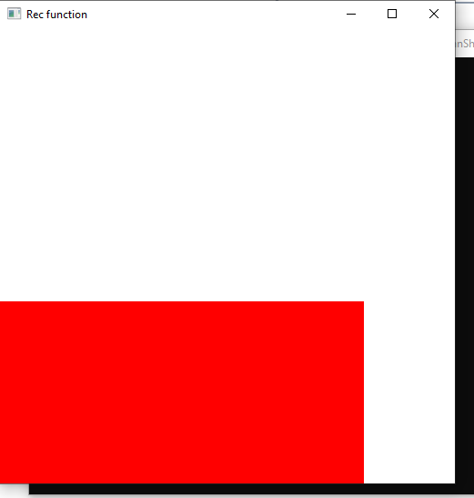

#include<Windows.h>

#include<GL\glut.h>

#include<math.h>

void myInit()

{

glClearColor(1.0, 1.0, 1.0, 0.0);

glPointSize(5.0);

glMatrixMode(GL_MODELVIEW);

gluOrtho2D(0.0, 500.0, 0.0, 500.0);

}

void display()

{

glClear(GL_COLOR_BUFFER_BIT);

glColor3f(1.0, 1.0, 0.0);

glRecti(30, 30, 400, 150);

glFlush();

}

int main(int argc, char** argv)

{

glutInit(&argc, argv);

glutInitDisplayMode(GLUT_SINGLE);

glutInitWindowSize(500, 500);

glutInitWindowPosition(150, 150);

glutCreateWindow("Assignment");

myInit();

glutDisplayFunc(display);

glutMainLoop();

}

